Coursework Assessment Report
Student ID: 22040610
Login Details: Email: test@test.com, Password: Test1234
Live Site Link: http://www.teach.scam.keele.ac.uk/prin/x8d44/grocery_store/
Word Count: 1959

Introduction

The Grocery Store Web Application implements a multi-tier architecture according to modern web development standards. It comprises:
- Presentation Tier: HTML5, CSS3, Bootstrap, and React for responsive interfaces with immediate feedback
- Application Tier: PHP controllers implementing business logic, security measures, and data coordination
- Data Tier: MySQL database storing product information, user credentials, and orders

This implementation follows the Model-View-Controller (MVC) pattern to enhance modularity and maintainability, with clear separation facilitating independent development of each tier.

Architectural Overview
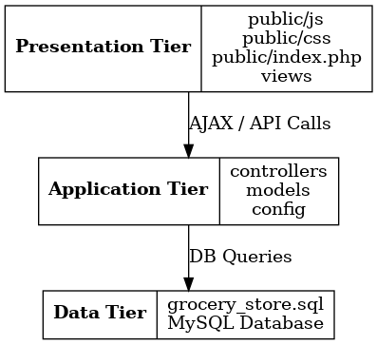
Figure 1: Three-tier architecture showing separation between presentation, application, and data layers with their associated technologies
The MVC pattern was selected because it:
- Clearly separates frontend and backend concerns
- Aligns naturally with PHP's request-response cycle
- Supports the RESTful API needs for manager functions
The architecture components interact through well-defined interfaces:
- Client browser sends HTTP request
- Router identifies appropriate controller
- Controller retrieves data from models
- Business logic processes the data
- View templates render the processed data
- Formatted HTML/JSON returns to client
This architecture enhances maintainability, enables targeted optimization, and isolates components for easier testing and security management.

Implementation Details & System I/O
Overall User Flow
The application implements the required user flow progression (Registration → Login → Product Selection → Order Submission) while maintaining security:
- Entry Point: User arrives at the homepage showcasing product categories with Vegetables and Meat options.
- Registration/Login: New users register with the React-validated form for name, phone, email, and password; returning users authenticate with credentials and CAPTCHA verification.
- Product Browsing: Users select categories via the AJAX-powered hierarchical dropdowns, exactly as required in the brief. When Vegetables is selected, it displays options for Potato, Carrots, and Broccoli; when Meat is selected, it shows Chicken, Fish, Beef, and Pork. This asynchronous loading enhances performance and user experience.
- Order Processing: Authenticated users add items to cart and proceed to checkout, with database transaction management ensuring data integrity during order placement.
- Manager Order Access: Managers access order data through the RESTful API with order ID parameters.
File organisation
grocery_store/
├── config/ # Configuration files and utilities
├── controllers/ # Request handling and business logic
├── models/ # Data access and business rules
├── views/ # Presentation templates
├── public/ # Client-accessible assets
│ ├── api/ # RESTful API endpoints
│ ├── css/ # Styling assets
│ ├── js/ # Client-side scripts
│ └── images/ # Product and CAPTCHA images
└── tests/ # Testing utilities

Multi-Tier Architecture
The application implements a clear separation of concerns using the MVC pattern. The structured file organization reflects the architectural boundaries:
This directory structure was designed to:
- Support Required Database Tables: Models interact with the three mandatory tables (products, users, orders), ensuring proper data management.
- Enhance Security: configuration and business logic files are placed outside the web-accessible directory.
- Promote Code Organization: Related files are grouped together, supporting the MVC approach.
- Facilitate Testing: Components are isolated for independent testing, ensuring robust functionality.
The router (public/router.php) serves as the central entry point, directing requests to appropriate controllers based on URL patterns. Controllers interact with models to perform data operations, then pass results to views for presentation. This architecture ensures the separation between data access, business logic, and presentation.
Key architectural benefits that address the module learning outcomes include:
- Maintainability: Localized changes don't ripple through the entire codebase
- Modularity: Components can be optimized or replaced independently
- Testability: Models and controllers can be unit-tested in isolation
- Security: Multiple layers protect sensitive operations

Registration & Login
The registration system uses React for real-time validation, providing immediate feedback as users type:
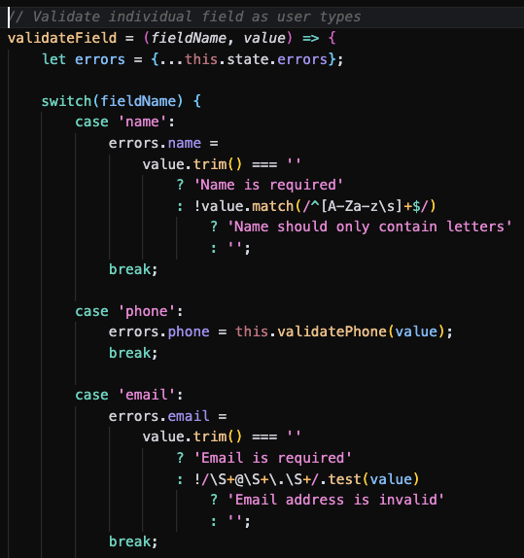
Figure 2: Registration form with real-time validation
Key implementation features:
- Client-side validation for name (letters only), phone (10 digits), email format, and password complexity
- Visual indicators showing validation state
- Server-side validation as security backup
- Password hashing using bcrypt
The login process implements rotating CAPTCHA verification and logging to prevent automated attacks:
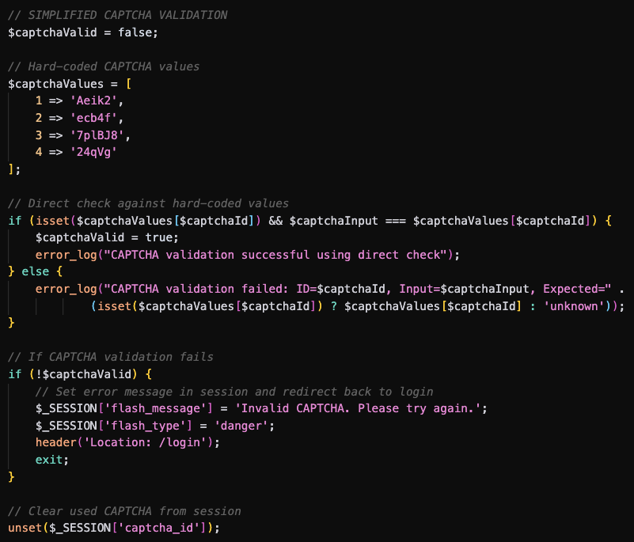 Figure 3: Login form with CAPTCHA implementation
This security measure:
- Requires human interaction for login attempts
- Maintains security context via session state
- Provides adequate protection while maintaining usability

Security Implementation
Security follows a defence-in-depth approach with multiple layers:
  - XSS Prevention: All output is escaped using htmlspecialchars()
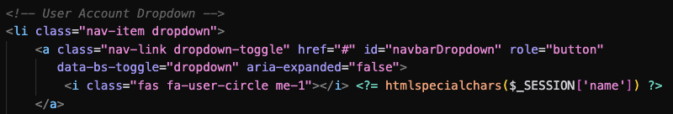
- SQL Injection Protection: Parameterized queries with PDO
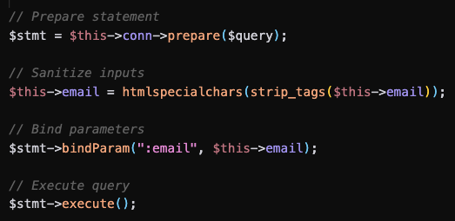
- CSRF Protection: Token-based verification for all forms
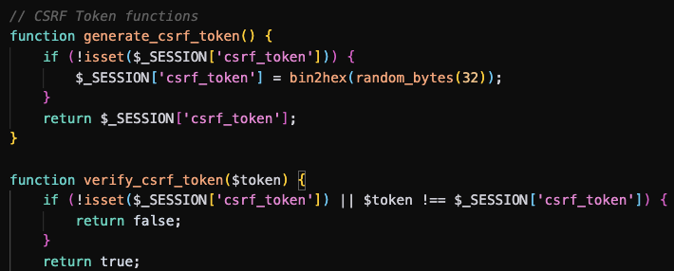
- Password Security: Bcrypt hashing with proper validation
This multi-layered approach ensures that vulnerabilities in one component don't compromise the entire system.

Search Engine Optimization
The implementation addresses both technical and content aspects:
- Meta Tags: Enhancing search engine understanding:
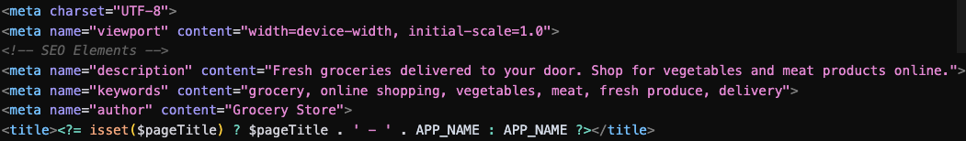
- Semantic HTML: Using proper HTML5:
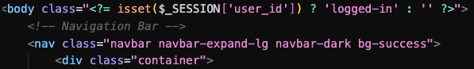
- Clean URLs: Implemented via custom router without .php extensions
- Image Optimization: Descriptive alt attributes for accessibility
- Mobile Responsiveness: Ensuring compatibility across devices

User Validation
Validation implements a layered approach combining immediate feedback with robust security:
- Client-Side React Validation: Implements real-time validation with immediate feedback for:
  - Name validation (letters only)
  - Phone validation (exactly 10 digits as required)
  - Email validation (format checking including @ and . characters)
  - Password validation (complexity requirements including uppercase, lowercase, and numbers)
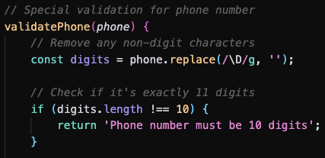
This validation occurs during keystroke entry, enhancing user experience by providing instant feedback without server communication delays.
- Server-Side Validation: Additional validation layer ensures client-side validation cannot be bypassed, with particular emphasis on email uniqueness checks to prevent duplicate email IDs in the database as required in the brief.
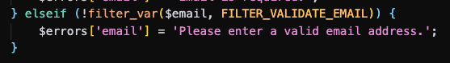
The validation implementation addresses multiple assessment requirements:
- Data Integrity: Ensuring properly formatted data enters the system
- Security: Preventing malformed inputs that could exploit vulnerabilities
- User Experience: Providing immediate feedback during form completion
- Technical Requirements: Meeting the specific validation rules outlined in the brief
This dual-layer approach ensures both a positive user experience and robust security.

Database & Database Management
The database implements a normalized structure with optimized relationships:
- users: Stores customer credentials with email uniqueness constraints
- products: Contains product details with category-based indexing
- orders: Tracks customer purchases with foreign key relationships
- captcha: Manages verification challenges
- cart: Handles shopping cart functionality with composite indexing
To ensure efficient database performance optimization, strategic indexes were implemented based on likely access pattern:
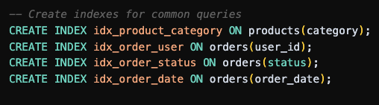
These indexes accelerate common query patterns:
- Category-based filtering: idx_product_category improves performance of AJAX-powered product filtering
- User-specific order retrieval: idx_order_user optimizes customer dashboard order history display
- Order status/date filtering: Enables efficient sorting in the manager API

RESTful Webservice
The manager API implements REST principles with token-based authentication:
GET /api/orders.php?id=123&manager_token=manager123
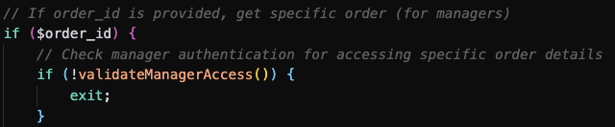
Figure 4: RESTful API endpoint implementation
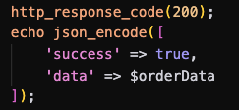
Figure 5: Standardized JSON response
The implementation supports:
- Order retrieval by ID with proper authentication
- Status updates via PUT requests
- Consistent error handling with appropriate status codes

System Inputs & Outputs
Input | Process | Output
Registration: User submits name, phone, email, password | React validates in real-time; server validates and stores hashed credentials | Success message and redirect to login, or validation errors
Login: User provides email, password, CAPTCHA | Server validates credentials and CAPTCHA response | Creation of authenticated session and redirect to products, or error messages
Product Browsing: User selects category from dropdown | AJAX request loads products for selected category | Updated product display with filtered items (see Figure 6)
Order Placement: User adds items to cart and checkouts | Server validates cart, creates order records, clears cart | Order confirmation page with details and status
Manager API: Manager requests order details with ID and token | Server validates token, retrieves order data from database | JSON response with complete order information
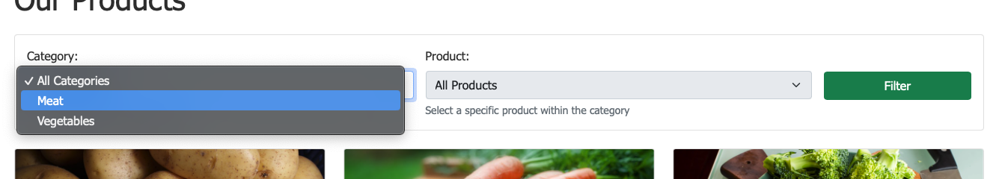
Figure 6: Product browsing with category filtering

Implementation Challenges
The development process encountered several significant challenges requiring strategic problem-solving:
Version Control Integration
Initially, version control was overlooked during early development due to implementation momentum. After reaching Stage 5, it was implemented retrospectively, requiring careful organization of existing files. This experience reinforced the importance of establishing version control from project inception, regardless of size of project and willingness to ‘plow ahead’.
PHP Server Compatibility macOS
When swapping out XAMPP for a local PHP server on macOS, several environment-specific issues emerged:
- Custom Routing Requirements
Unlike XAMPP’s fixed htdocs root, PHP’s CLI server needs a custom router.php to handle “pretty” URLs, AJAX endpoints and SPA routing.
- Safari HTTP
Strict CORS and fetch behaviours in Safari caused API-call failures. Was temporarily bypassed HTTP (using direct CLI scripts) or switched to Chrome for endpoint testing.
- Unbounded Server Timeouts
Long-running API tests would hang the CLI server indefinitely. Resolved this by adding explicit stream timeouts.
Debugging Complexity in Multi-Tier Applications
As application complexity increased, identifying error sources became challenging due to interactions between:
- JavaScript console errors
- PHP server logs
- MySQL database errors
- Network request/response cycles
This was addressed by implementing the ErrorLogger class to centralize error reporting across application tiers.
AJAX Implementation and Cross-Origin Challenges
Product filtering implementation encountered CORS issues when testing across different environments. This was resolved by implementing proper CORS headers and ensuring consistent environment configurations. UX was further refined for mobile design.
React Integration with PHP Backend
Incorporating React while maintaining server-side security created challenges with:
- Managing state between components and PHP sessions
- Ensuring validation consistency
- Handling CSRF token verification
The solution involved creating a bridge mechanism using data attributes and global variables to securely pass session data to React components.
CAPTCHA Session Management Issues
CAPTCHA implementation encountered session persistence issues when users navigated between pages. These were resolved through more robust session handling and improved error messaging.

Task Template Summary
Task | Implementation status
Grocery company webpage | Implemented AJAX-powered product browsing with hierarchical dropdowns and responsive design
Sql tables | Created normalized database schema with appropriate relationships, constraints, and indexes
Registration page | Implemented React validation with real-time feedback for name, phone, email, and password
Login with captcha | Integrated session-based challenge-response system with secure session management
Security aspects | Implemented XSS protection, SQL injection prevention, CSRF verification, and secure password storage
Seo | Added semantic HTML, meta tags, alt attributes, and clean URL structure
User validation | Created comprehensive validation with visual indicators and server backup validation
Data management | Designed normalized schema with strategic indexing and transaction support
Restful webservice | Implemented token-authenticated API with proper status codes and error handling

Suggested Improvements
Core Functionality Enhancements:
- Advanced Product Filtering: Expanding the AJAX-based filtering to include price ranges and other attributes, enhancing the existing dropdown implementation while maintaining the required structure.
- Enhanced CAPTCHA Security: Implementing more challenging yet accessible CAPTCHA variants to further strengthen the login security measures already in place.
- Expanded Validation Rules: Adding more sophisticated client-side validation patterns while maintaining immediate feedback.
Technical Implementation Improvements:
- Enhanced SEO Implementation: Further optimization of semantic HTML structure and metadata to improve search engine visibility.
- Advanced MVC Pattern Usage: Implementing more sophisticated controller structures to enhance the separation of concerns already established.
- Expanded RESTful API: Adding more endpoints to the manager API while maintaining the token-based authentication approach.
Performance Optimizations:
- Improved Database Indexing: Further refinement of database index strategies to enhance performance of the AJAX filtering system.
- Client-Side Caching: Implementing browser caching for product data to reduce server load during browsing sessions.
- Optimized Image Loading: Implementing lazy loading for product images to improve initial page load performance.
These suggested improvements directly enhance the required features of the assessment, while not adding features outside the scope of the brief requirements.

Conclusion
The Grocery Store Web Application successfully fulfills all assessment requirements, demonstrating comprehensive implementation of advanced web technologies. The multi-tier architecture and MVC pattern provide clear separation of concerns, while security measures implement defence-in-depth principles.
The React-based validation enhances user experience while maintaining robust server-side checks, and the RESTful API provides management functionality according to industry standards. The responsive design ensures compatibility across devices, while database optimization balances normalization with performance considerations.
This implementation demonstrates technical competence across multiple web technologies while considering real-world requirements including security, usability, and performance factors.

